**SmartAgCloud**

**IOT-Based Agriculture Network Infrastructure Manager**

**Component Design Document**

CMPE 281

Spring 2019

Professor:

**Jerry Gao <Jerry.gao@sjsu.edu>**

**Individual Submission by**

Hemaprasanthi Mutyala

[hemaprasanthi.mutyala@sjsu.edu](mailto:hemaprasanthi.mutyala@sjsu.edu)

Student ID: 013704392

Contents

1 System Overview 3

2 System Infrastructure and Architecture 4

2.1 Cloud based System Software Layer 5

Web Server 5

Mirror Server 5

2.2 Simulated Station Physical Layer 6

2.3 System Scalability Design and Implementation 7

2.4 System Load Balance Design and Implementation 8

3 Technology Used 9

4 Functional Components 10

4.1 IOT Based Infrastructure Manager 10

5. IOT-Based Cloud System Design and Services 11

5.1 System Services 11

5.1.1 Infrstructure Manager Services as a Usecase Diagram 11

5.1.2 Infrstructure Manager Services as a Sequence Diagram 12

5.1.3 Infrstructure Manager Services as a Class Diagram 13

6.GUI Design 14

6.1 Home Page View 14

6.2 Dashboard View 15

6.3 Map View 15

6.4 Cloud View 16

## 1 System Overview

This project is designed to develop, implement, and validate an IOT-based cloud infrastructure system as a SaaS for Smart Agriculture. Each ranch is equipped with a set of sensors. Each smart node is in turn connected to a cluster which will be used to control the connected smart nodes and support the communications with the back-end server to send the collected sensor data for all nodes. Each smart node has wireless communication capability which supports node-to-node and node-to-cluster communications.

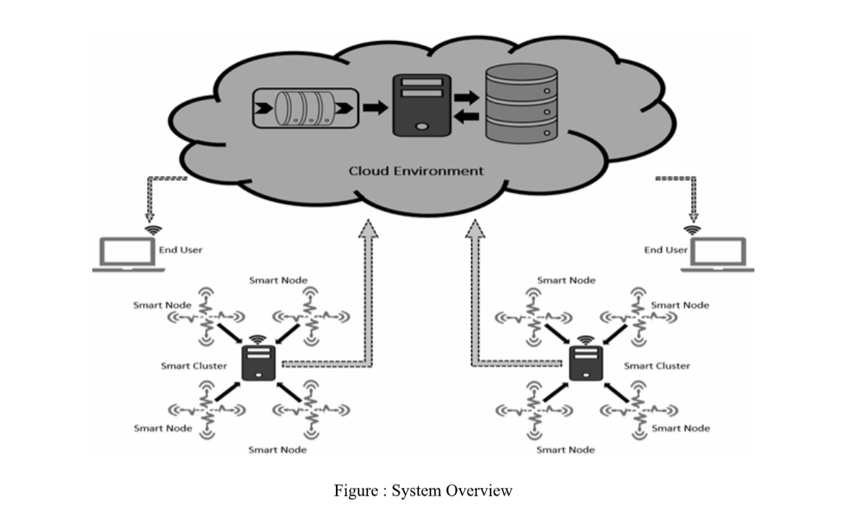

## 2 System Infrastructure and Architecture

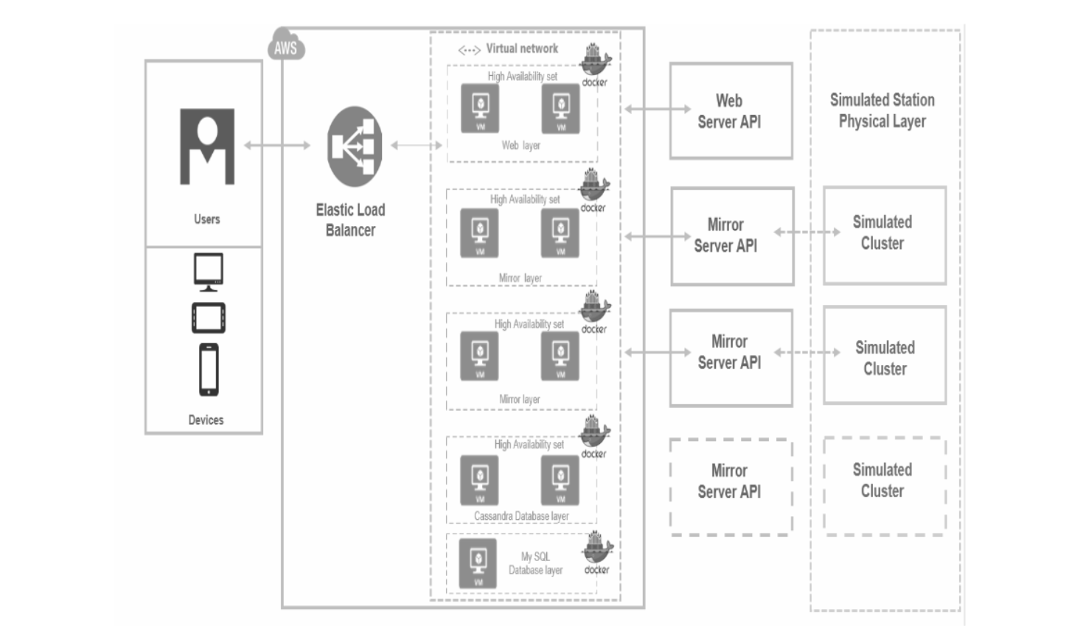

Figure: System Infrastructure

The system infrastructure has two main components:

1. Cloud Based System Software Layer
2. Simulated Station Physical Layer

### 2.1 Cloud based System Software Layer

This layer is hosted on the AWS cloud environment and controls the entire big data sensing of the system, under use. Each Component runs in a Docker container as a docker image. The servers constituting the cloud based system are:

#### Web Server

This is the master server responsible for handling all cloud based activities and services by itself or by calling the respective Mirror Server.

#### Mirror Server

This server acts a reflection of the simulated physical cluster in the cloud based system. There is one to one dependency from Mirror Server to a simulated cluster.

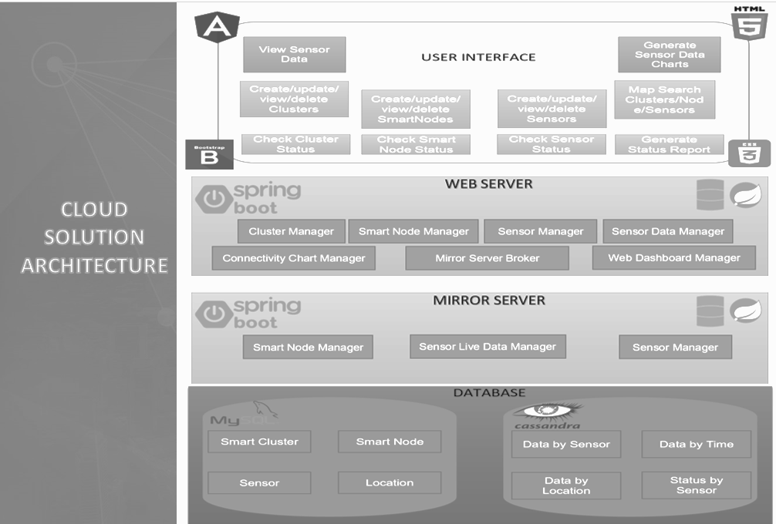

### 2.2 Simulated Station Physical Layer

Simulated Station Physical Layer is a simulated representation of the layer on the ground with real physical clusters. A physical cluster will consist of several smart nodes which will be connected to the cluster through a serial bus connection. The smart nodes shall have a set of sensors attached to them. The physical cluster shall have the connectivity to the internet required to push the big data from the sensors to the cloud.

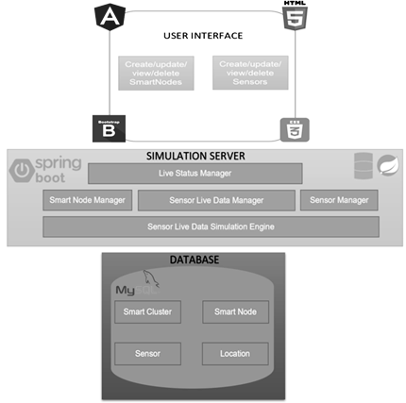

Figure : Simulated Station Solution Architecture

### 2.3 System Scalability Design and Implementation

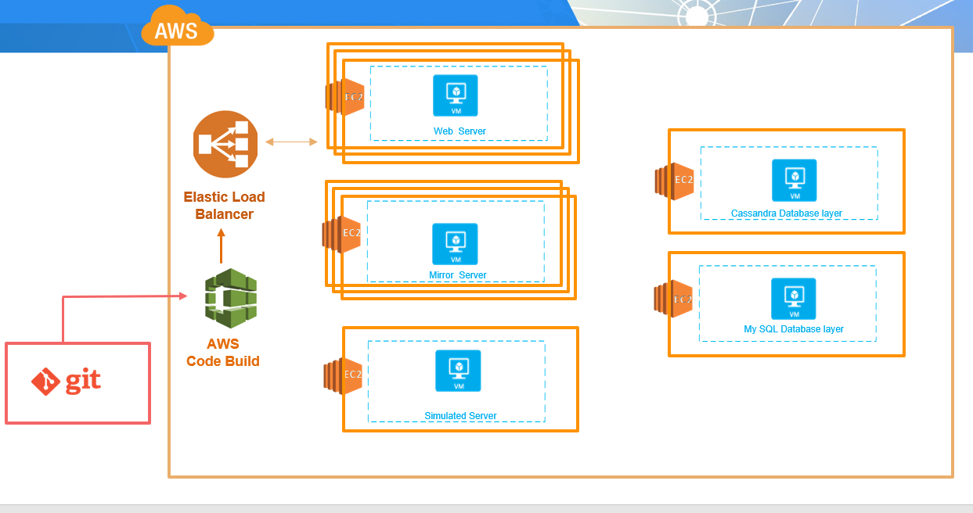

Our scalability can be seen in the following points:

1. The part of the system scalability is that we have mirroring server for each real cluster. That means when we add more physical clusters our system will receive additional mirroring server and will never be overloaded.
2. The second element is that we have stateless web-server cluster, that means we can add mode web-server nodes into cluster in terms to respond to increased payload.
3. The third element is the Reddis clusterization, we can horizontally scale the Reddis cluster to support very big data set.

### 2.4 System Load Balance Design and Implementation

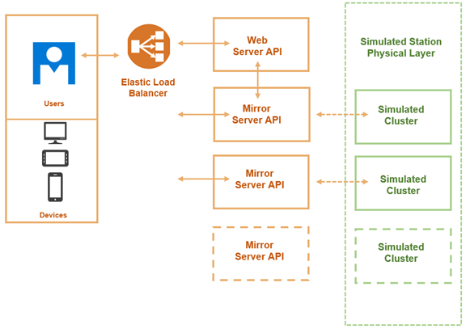

## 3 Technology Used

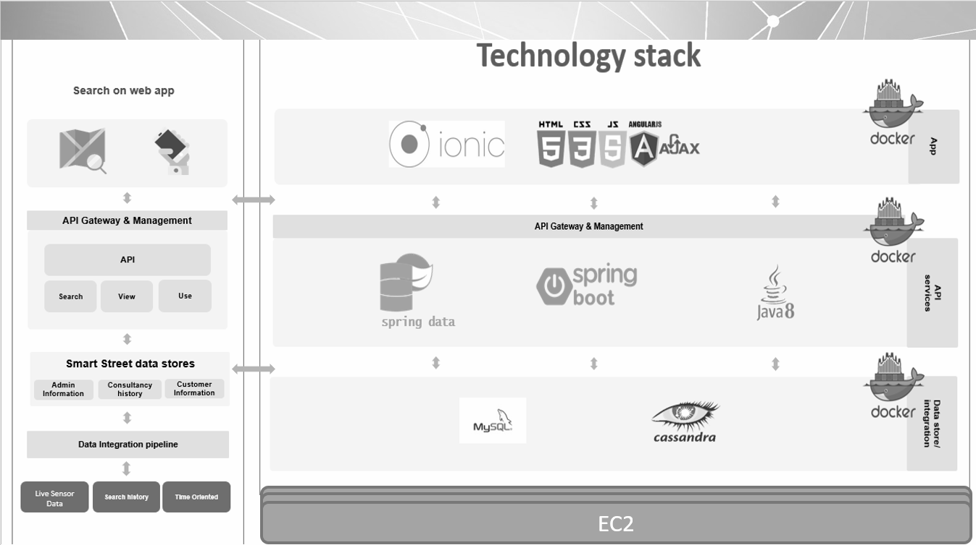

## 4 Functional Components

### 4.1 IOT Based Infrastructure Manager

The major functionalities of this component are:

1. Cluster node management:

add/update/delete/view cluster nodes and track cluster status.

1. Smart node management:

add/update/delete/view smart nodes controlled by a cluster, and track node status.

1. Sensor management:

add/update/delete/view sensors from a selected smart node sensor, and track sensor status.

1. Display and generate a status report on an existing IOT smart ranch infrastructure.

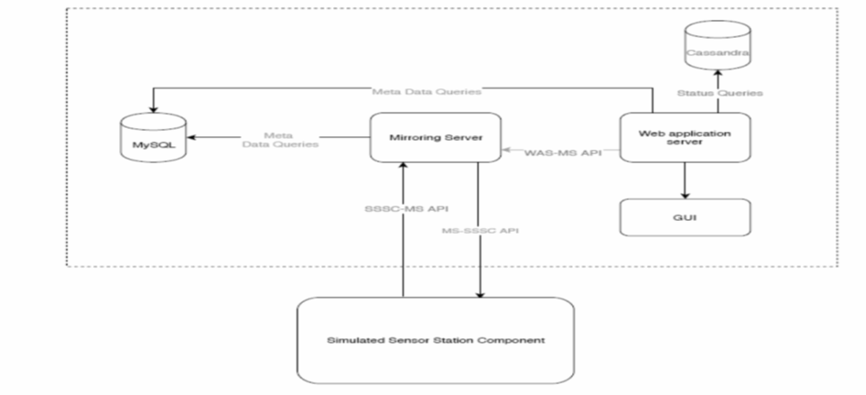

Figure : IOT Based Infrastructure Manager API Design

## 5. IOT-Based Cloud System Design and Services

### 5.1 System Services

The system services can be categorized into five major functional services

#### 5.1.1 Infrstructure Manager Services as a Usecase Diagram

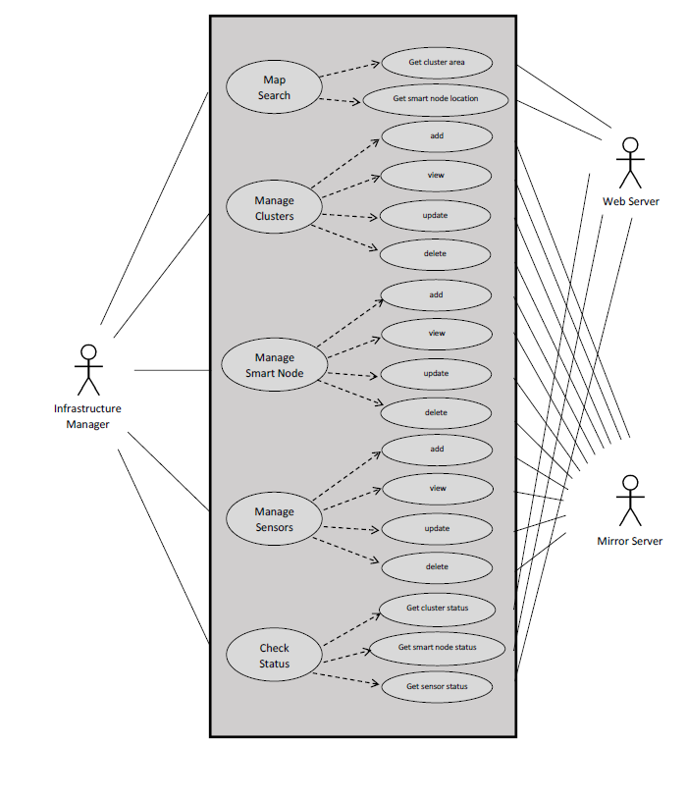

Figure : Infrastructure Manager Services

#### 5.1.2 Infrstructure Manager Services as a Sequence Diagram

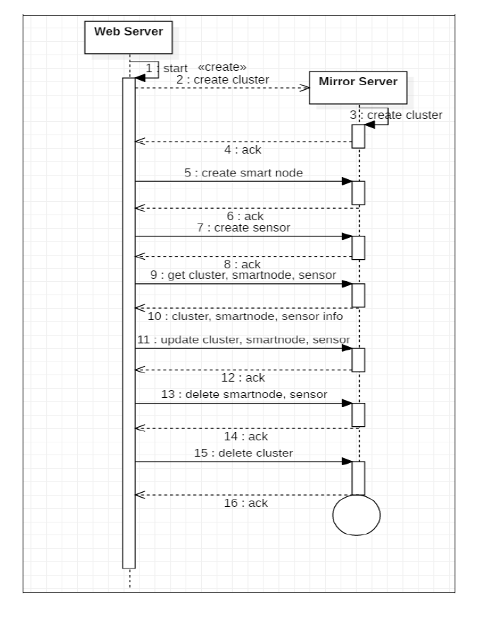Figure : Infrastructure Manager Service Sequence Diagram

#### 5.1.3 Infrstructure Manager Services as a Class Diagram

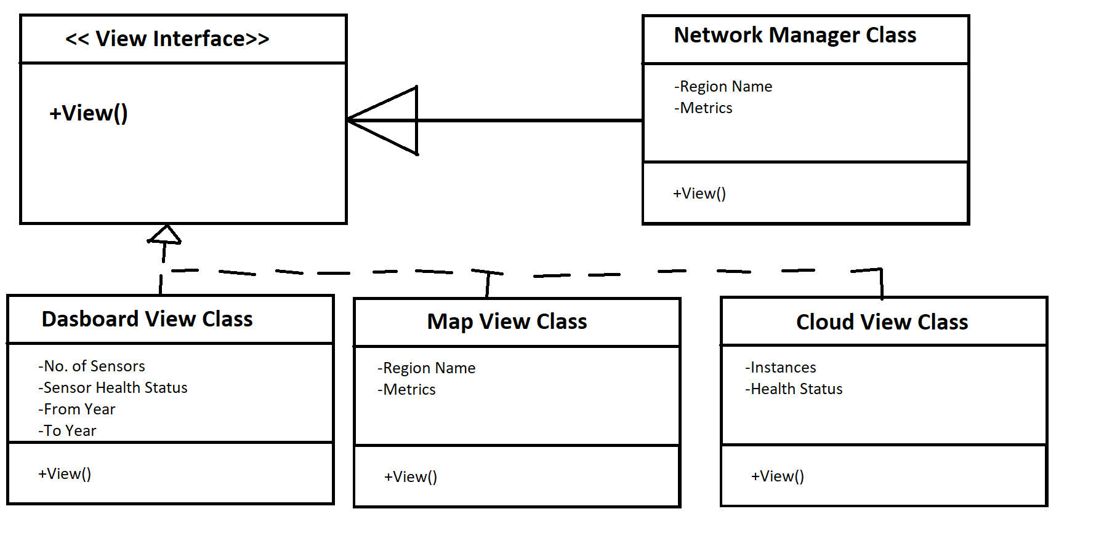

Figure : Infrastructure Manager Service Class Diagram

## 6.GUI Design

### 6.1 Home Page View

**

### 6.2 Dashboard View

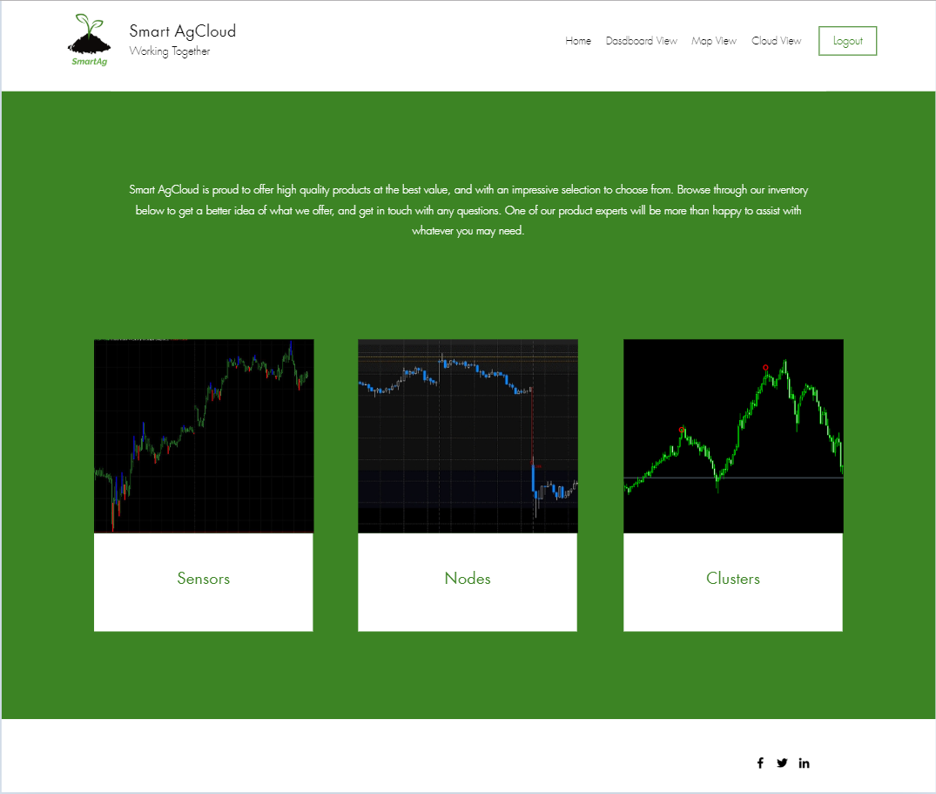

### 6.3 Map View

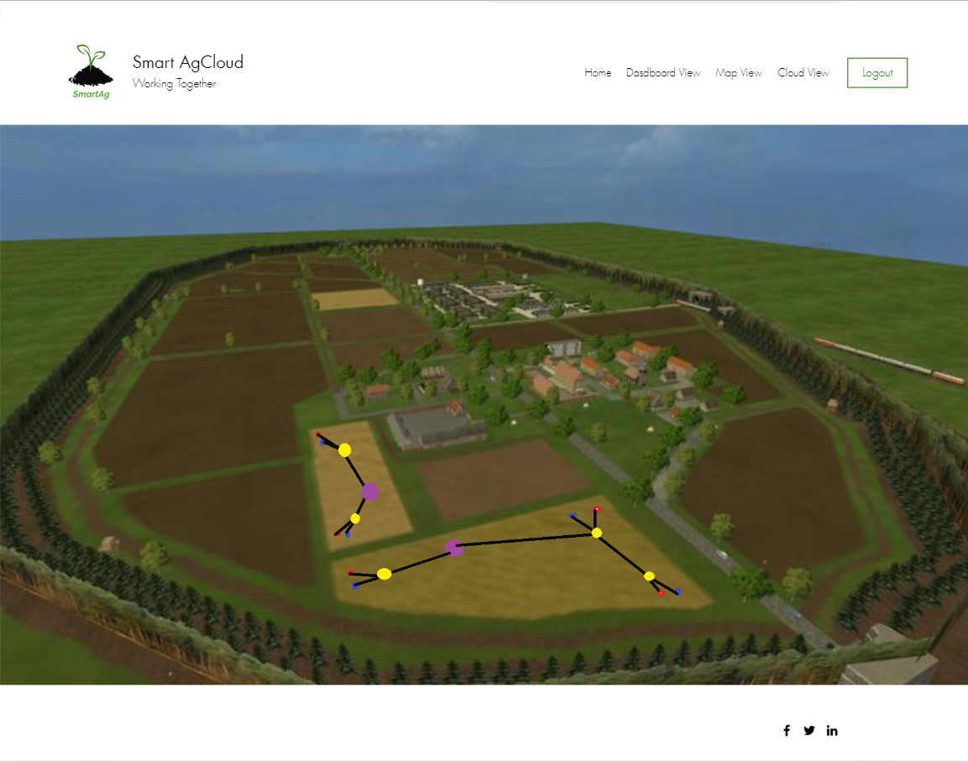

### 6.4 Cloud View

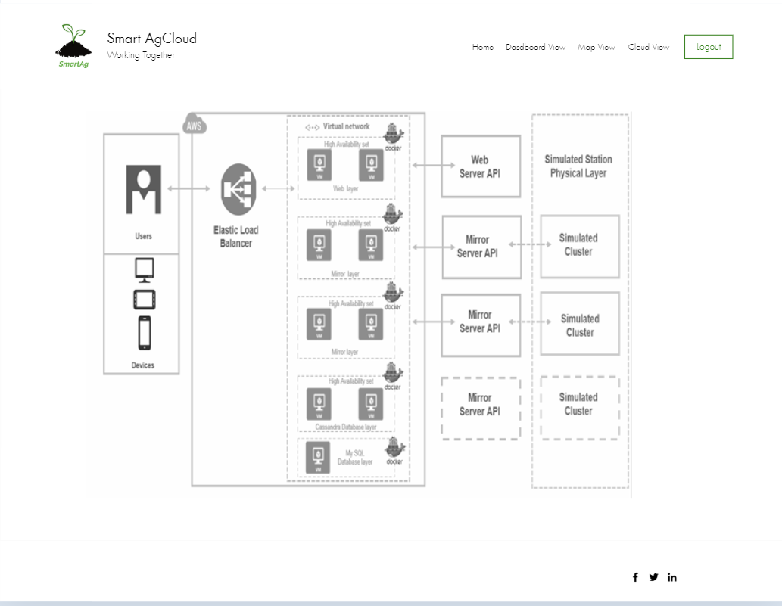

The Home Page GUI provides the following information:

1. Component responsibilities
2. 3 different views of IOT network management

The Dashboard view provides the following information:

1. Health status of all the sensors in a region in the current month
2. Health status of all the nodes in a region in the current month
3. Heatlh status of all the clustors in a region in the current month

The Map view provides the following information:

1. Different sensors installed ( red is temperature sensor, blue is soil moisture sensor)
2. Location of the sensors installed
3. Network connectivity between the sensors and nodes (connectivity is represented in black)
4. Network connectivity between the nodes in a mesh network (represented in yellow)
5. Network connectivity between the nodes and the clustors (clusters are represented in purple)

The Cloud view provides the following information:

1. Complete cloud architecture